Publisher Title Year

Name

Bio

Country

Book

Authored

Author

URF

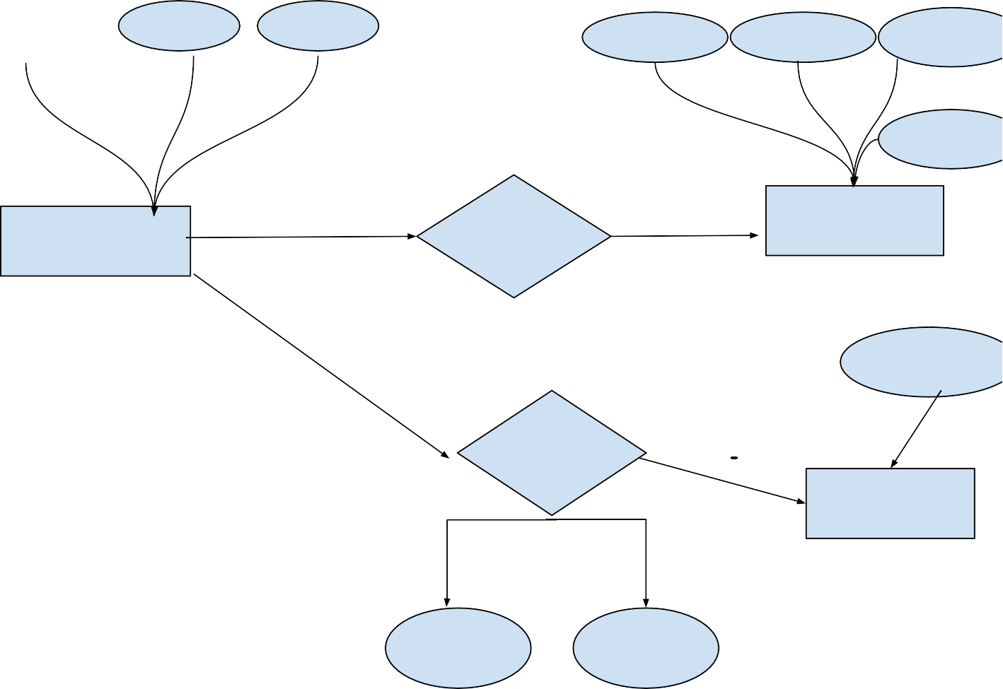

IDCard

Borrow

Reader

Borrowed Returned